Year 6 Home Learning
Week beginning 13th and 20th July 2020

Dear Year 6,

We hope that for those of you who attended school over the last few weeks that you enjoyed the opportunity to be with your friends and in the school environment. We really enjoyed having you back in school and being able to spend time with you before you leave Berrywood to begin your next adventure at secondary school. Congratulations on a very successful seven years at Berrywood Primary School. You should feel very proud of all you have achieved and the wonderful people you are. It has been a pleasure to teach you this year and we have been very proud of how much you have developed and grown despite your final year at Berrywood looking a little different because of the Covid-19.

Below are some activities that you can complete for your home learning for the remaining eight days of term. They are based around reflecting on your time at primary school and looking to the future at secondary school. We hope you enjoy them as well as being able to spend time outside and with your families.

Maths:

Times tables: Each day there will be some set work for you to complete on Times Tables Rockstars. This will consist of different game types, in the ‘garage’ in the ‘studio’ and ‘soundcheck’. Of course, once you have completed these, you can keep playing, try out new game features and spend your earnings! Try to aim for 20 minutes a day on this.

Theme Park Maths Investigation:
We are continuing to work on the investigation where you will plan, design and operate your very own Theme Park.
The whole pack has been previously emailed, should you wish to look at it all.
(There are printed versions of this pack available from school should you need it and feel able to collect.)

Over the remaining eight days, please complete the Theme Park Maths investigation.

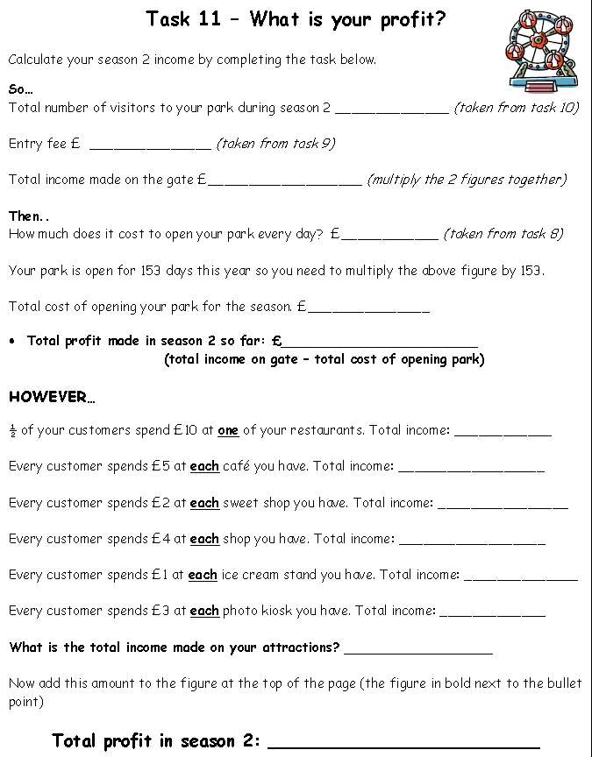

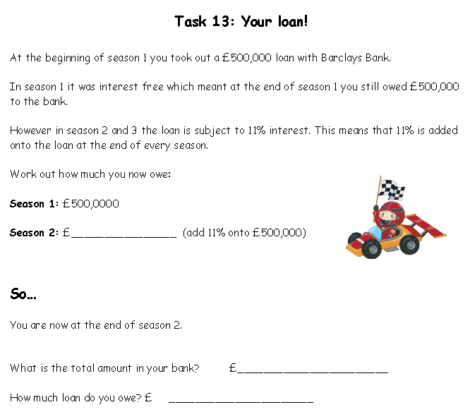

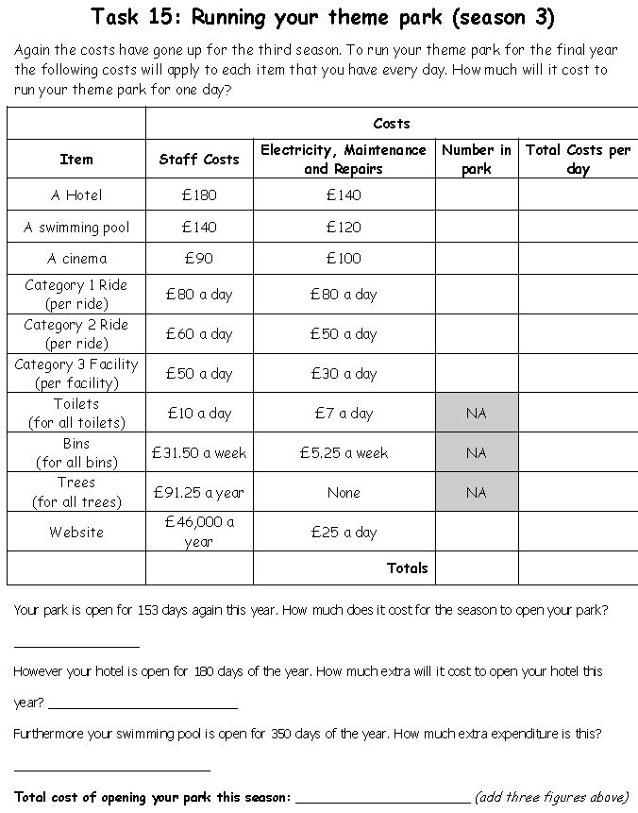

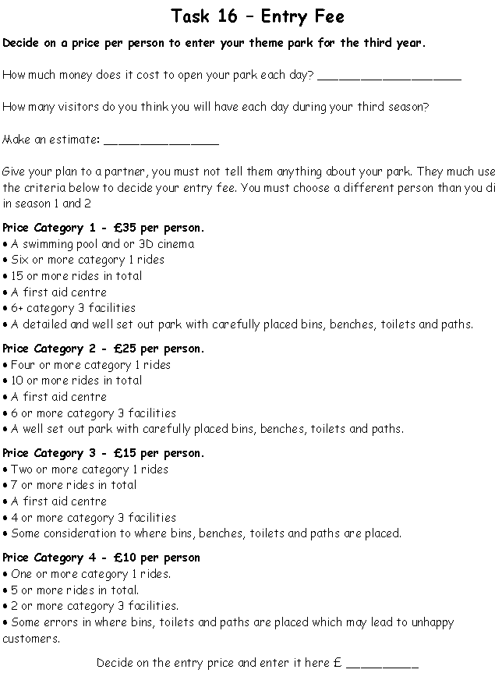

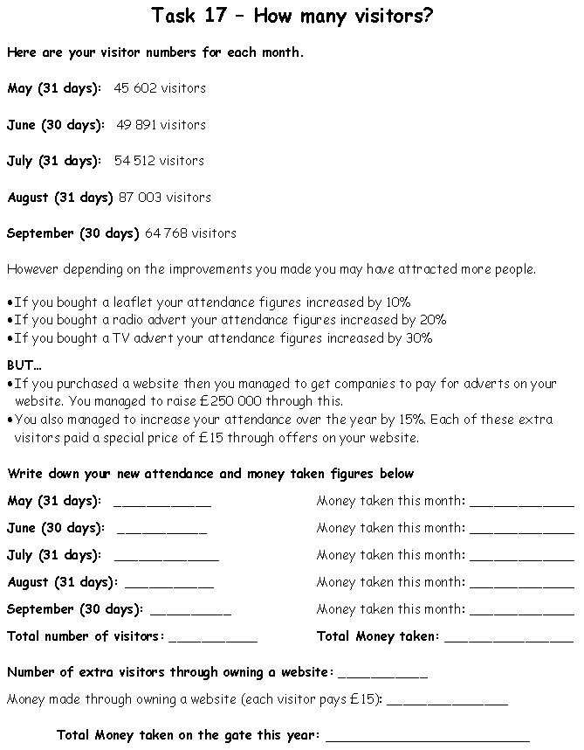

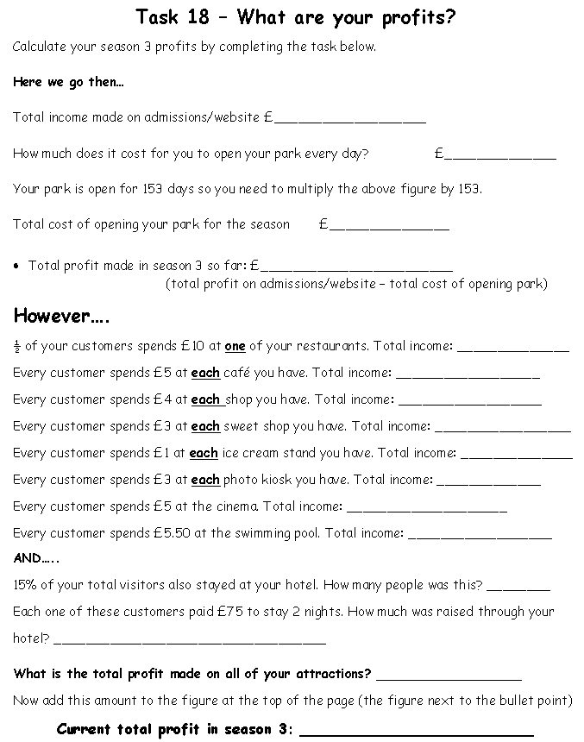

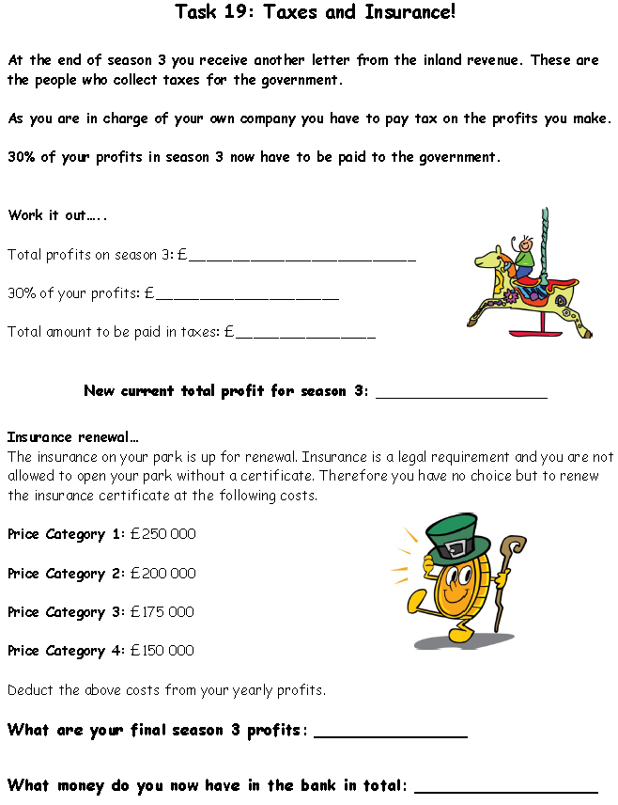

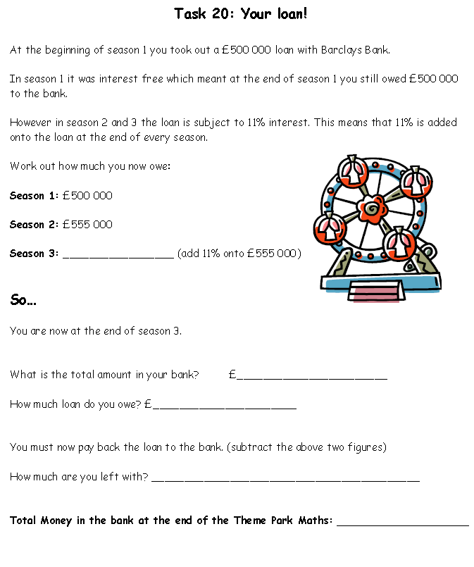
If you finished Theme Park Maths at school, there is an alternative activity for you to complete at home:

Using BBC bitesize, https://www.bbc.co.uk/bitesize/subjects/z826n39 recap and revise some of the maths topics we have covered this year. There are games to play, videos to watch and plenty of questions to have a go at.

This covers all of the mathematical concepts we have looked at this year, including:
- Problem solving
- Number
- Algebra
- Fractions, percentages and ratio
- Shape
- Data

You could also tackle some mystery multiplication colouring. Using your times tables knowledge, colour the squares correctly to reveal a mystery image.

There are lots on this website but be sure to challenge yourself and pick ‘advanced’. https://www.coloringsquared.com/free-coloring-pages-math-for-kids/math-fact-coloring-pages/free-multiplication-worksheets-math-kids/mystery-multiplication/
Perhaps you could also make your own!

English:
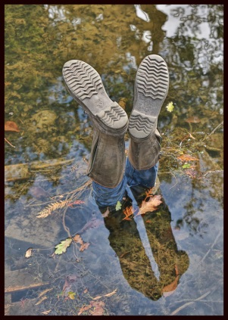

Activity 1: Write the story to accompany this image. Think carefully about how you will develop your characters and settings, using known devices. How will you build suspense within your short story and use vocabulary, punctuation and grammar to have a particular impact on your reader? Consider the age of your audience and ensure you have used vocabulary and grammar appropriate for this.

Activity 2: Continue to add to and create your scrap book. You may wish to include different forms of writing in your scrap book such as a diary of your favourite day, or a letter to your future self for example. Try and include a variety of different forms of writing and consider breaking this up with photos, images and illustrations.

Reading:

Read three times a week and record this in your reading log.

Project:

Activity 1: Complete the transition activities sent out by your secondary school. For children going to Wildern, this is the ‘Best of Me’ activities you have been sent via an email from Wildern School. Remember to include as much information as possible about yourself so that your tutor has the opportunity to learn as much about you as they can before you begin secondary school in September.

If you are not going to Wildern, you may have been sent some alternative transition activities. However, if not, it would be great if you could create a profile about yourself that you could send your new tutor or you might like to write a letter to introduce yourself and explain what you are excited about and what you are a little apprehensive about.

Activity 2:

Enjoy spending time outside and with your families reflecting on your achievements and very successful years at Berrywood Primary School.

Other learning opportunities:
- PE with Joe https://www.youtube.com/watch?v=faE7889AIaU
- Science with the Winchester Science Centre https://www.winchestersciencecentre.org/science-home/science-home/#.Xor4d4hKhPY
- Let’s Think English lite https://islingtongovuk.j2bloggy.com/lteprimary/
- Times tables rockstars
- 5 - a - day (aim for gold but you may want to build your confidence with bronze or silver or challenge yourself with platinum) https://corbettmathsprimary.com/5-a-day/
- Purple mash activities

Submission of work:
Please submit your work using the purple mash email address by Friday at 5pm each week. The instructions below will help you to know how to do this:

Emailing on Purple Mash – KS2
- Search email in the search bar
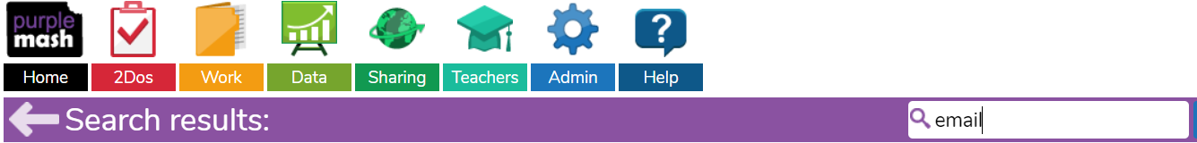
- Click on 2Email - it needs to be the tools and games version
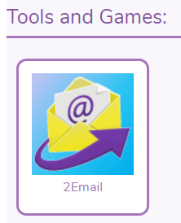
- Click on compose
- In the To section type in your Class Teacher’s name e.g. Miss Cunningham, Mr Rolfe, Miss Lowe
- To send us your work, click on attach work and choose the file you wish to upload. You can send work created in Purple Mash and work saved to your own electronic devices e.g. desktop/ laptop/ tablet
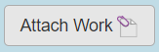

To upload photos to an email, please follow the instructions below:

  - Open 2simple email.
.
  - Compose new email.

  - Add your teacher’s name to the field and click on ‘attach picture’.
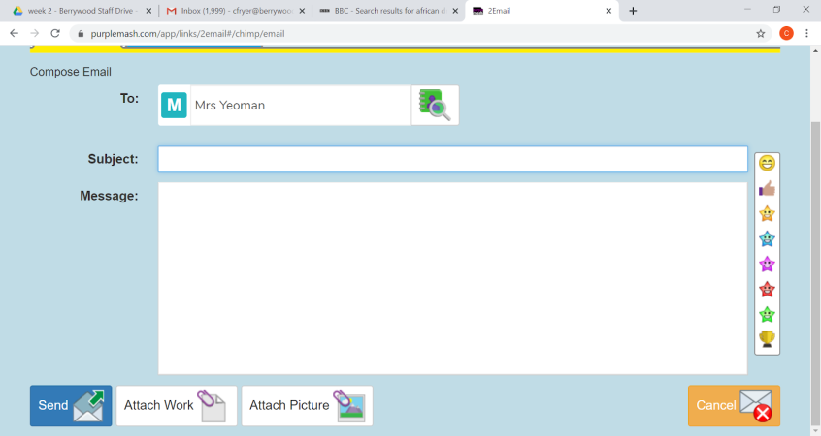

  - Click on the 2nd icon – clipart.
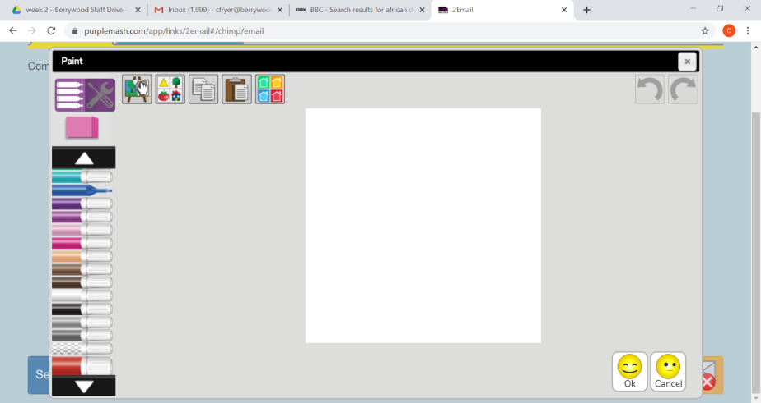

- Click on ‘choose file’.
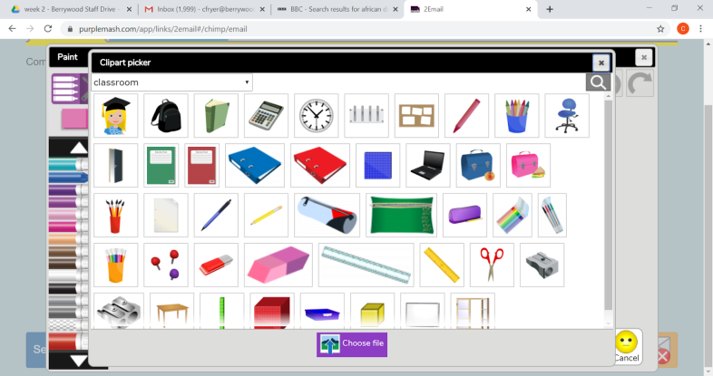

- You should then get the option to choose a file from your device. If you are using a tablet or phone, it will give you the option ‘get photo’ and you can choose from your camera roll.
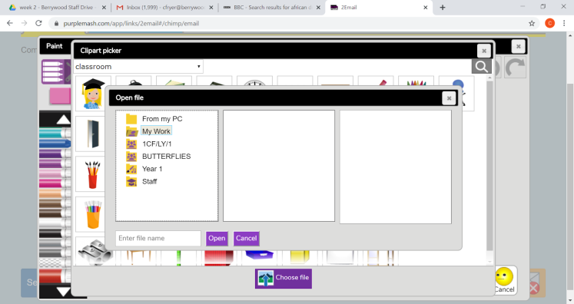
Keep safe and have a wonderful and very well deserved summer break. We have thoroughly enjoyed teaching you and know you will all go on to be very successful when you begin your next adventure at secondary school in the Autumn Term.

With our very best wishes,

Miss Cunningham, Mr Rolfe and Miss Lowe

