Year 1 Home Learning
Week Beginning 6th July
A note from the Year 1 team…
We hope you are enjoying the new Home Learning activities and we continue to look forward to seeing your creativity and hard work on Purple Mash. We also really enjoy hearing about all of the exciting ways in which you are learning and having fun at home.
The aim again this week is to complete as many of the following activities as possible:
English – 1 weekly activity and daily deliberate practice Project – 1 weekly activity
Maths – 1 weekly activity and daily deliberate practice Science – 1 weekly activity
There are also still extra learning activities for those who want more of a challenge!
We would love for lots of you to try these too.
Have fun and keep learning!
Project
‘Once Upon a Time’
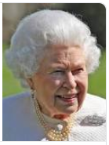
In our project work this week we would like you to review and reflect on the things you have found out about our current monarch Queen Elizabeth II.
We would like you to look at the power point presentation about the Queen (attached to this email) as well as the short clip taken from Newsround a couple of years ago.
https://www.bbc.co.uk/newsround/44370212
Looking at the pictures and statements on the next page, can you work out which are true and which are false?

You could cut the pictures out and sort them into two groups.

You may like to make up your own true and false quiz about The Queen or about other monarchs you have learnt about over the past few weeks. Try testing your family’s knowledge too!

When she was a little girl, the Queen enjoyed going to school. | The Queen has four children, one girl and three boys. | The Queen was 25 when she got married.
Elizabeth became Queen when she was 25. | The Queen is the head of the Armed Forces. | The Queen lives in Kensington Palace.
The Queen spends time at her other homes, Windsor Castle, Balmoral and Sandringham. | The Queen’s favourite breed of dog is the Corgi. | Queen Victoria was Queen for longer than Queen Elizabeth II.
The Queen sends a special letter to people on their 100th birthday. | The Queen served in the Armed Forces. | The next in line to the throne is Princess Anne.
The Queen has 10 grandchildren. | The Queen got married in St Paul’s Cathedral. | The Queen had one sister and one brother.

Maths

Last week we were looking at the part-part whole model, the cherry diagram. This week we will be investigating the bar model which is another part-part whole model.
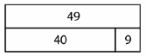
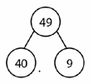
When using this model the large bar is used to represent the whole and the two smaller bars are used to represent the parts. e.g.

Can you read these stories and place the numbers in the right parts of the bar model?

There are 49 grapes in a bowl. There are 53 cows in a field.
I ate 9, now there are 40 left. 50 of them are black and 3 are white.

In a bag there are 27 coins. 36 sheep were in a field.
I used 20 and 7 were left. Thirty were standing up and 6 were
lying down.

There are 20 girls and 9 boys in First there are 6 people on a boat
a class. Altogether there are 29 Next 60 more people get on.
children. Now there are 66 people on the boat.

Now have a go at working out the missing part.

Toby had 53 cars. He lost 3 of them. There were 20 blue birds in a tree and
How many did he have left? 7 red birds. How many birds were there altogether?

Challenge
Now try writing your own stories for a bar model.

English
Once Upon A Time…
This week we would like you to continue to write and illustrate your own traditional story.
Using your story plan, from two weeks ago, continue to write your story. Think about how you will describe the setting, the characters and how you will explain what is happening in your story. It might be useful to read your sentences out loud to someone else, to check that your story is clear. You might ask someone else to read it aloud to you, so you can hear if anything needs to be added or changed. This will help you to check that you have used all the words you need and that your sentences are correctly punctuated (remember to check your writing for full stops, capital letters and finger spaces). You might try to challenge yourself by using an exclamation mark!
Once you have finished writing, you could write a blurb to put on the back of your book! Also, remember to give your story a title and to illustrate it.

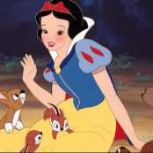
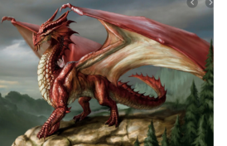
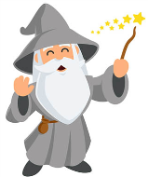
Science
For the next two weeks we would like you to continue your research on your chosen mini beast and to collect some information that you could use to create a fact-file. This will be similar to the sea creatures fact-file you completed in school.

You will need to find out about variations in the species, for example, different types of butterfly and their names or different types of ladybird. What are the differences? You will also need to know about their habitat and what they eat.

You could organise your fact-file under different headings e.g. ‘What do they eat?’ or ‘Habitat’. You could also try to include a fascinating fact.

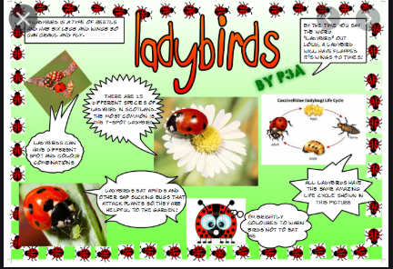

R.E.
This week we will be thinking about authority and who tells us what to do.
Talk to an adult about your own experiences of being told what to do or telling somebody what to do.

- Who tells us what to do?
- Why do we do as they say?
- Would you do something silly if you were asked to?
- Who do you trust to tell you what to do? Why?
- What sort of things are you asked to do?

We would like you to create a mind map of who you think has authority. Can you explain why you have chosen them?

What is authority?
Who has authority?

Once you have created your mind map and talked about it, finally we would like you to write a sentence explaining whose authority you listen to and why e.g. I listen to my mum because she is trying to keep me safe.

Daily Deliberate Practice
Please access each of these activities for up to 20 minutes a day
- Numbots
- Reading – please look at www.oxfordowl.co.uk for a free e book library. If you look under the ‘levels’ tab, there is an option for ‘Book Band’, here you can click on the band your child is reading. (This is on a sticker on the side of their current reading book, please contact your class teacher if you are unsure).
- Phonics – please access https://www.phonicsplay.co.uk/ (login: march20, password: home) This week our focus is adding the prefix un to words kind becomes unkind, lock becomes unlock Talk about what happens to the meaning of the root word by adding un. You could also play Forest Phonics https://www.ictgames.com/mobilePage/forestPhonics/index.html
- The phonics programme we follow at school is called Letters and Sounds. Please try and watch the daily lessons focussing on phonic sounds that your child would be covering if they were in school. These lessons guide you through a half hour phonic lesson concentrating on the different sounds . These are launched daily at 10.30, but can be watched anytime after this and previous lessons can also be watched. Although they may not follow the same sound that we are looking at that week they are helpful to support phonic awareness and recall. https://www.youtube.com/channel/UCP_FbjYUP_UtldV2K_-niWw
- Spelling- Choose from the word lists below and learn how to read and spell some of the different words with the different spellings.

un
undo
untie
unload
unkind
unlock

When you have learnt some of these words, challenge yourself to write them in a sentence. Don’t forget capital letters, full stops and finger spaces!
Common Exception Words (CEW)- learn how to spell these tricky words
ask, friends, school, by

Uploading work
Once your child/children have completed the different learning tasks it would be great to see their work. Please can you upload photos or attach files and send these using their Purple Mash logins. Please see below how to change settings to send and receive emails using Purple Mash.

