Year 2 Home Learning
Week Beginning 8th June 2020

We really enjoyed looking at all of your home learning last week. We also enjoyed speaking to your families and hearing what you did during half term. We are so pleased with the determination that you are showing towards your home learning and we look forward to seeing your learning this week.

Daily Activities
- 20 minutes - Numbots: https://play.numbots.com
- 20 minutes - Spelling Shed: https://www.spellingshed.com
- 20 minutes - Reading for Pleasure. This can be independent or with an adult. The children can access ebooks on the Oxford Owl website on www.oxfordowl.co.uk

English

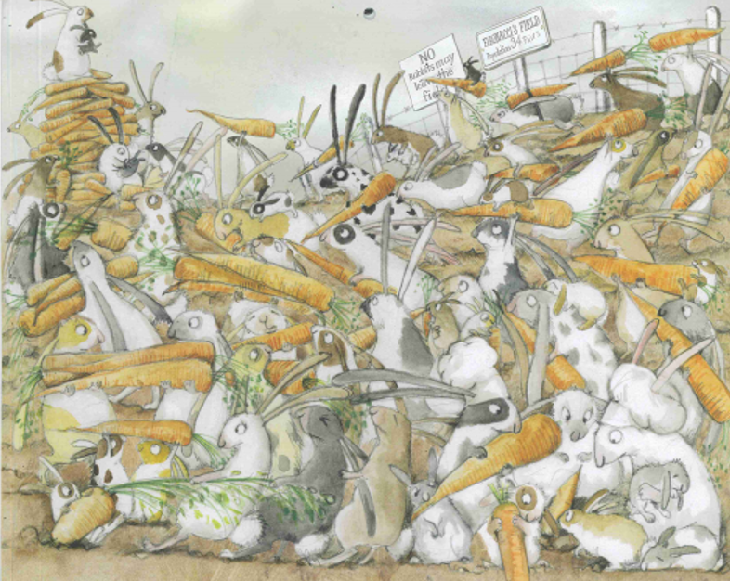
This week, we will be looking at pages from Emily Gravett’s book The Rabbit Problem. This book is set out as a calendar with the rabbits experiencing a different problem each month. The rabbits then find creative ways to solve the problems.

We have attached a document with the pictures for you to use.

Activity 1
Have a look at the ‘Too Many Carrots Problem’ page, it looks like this.

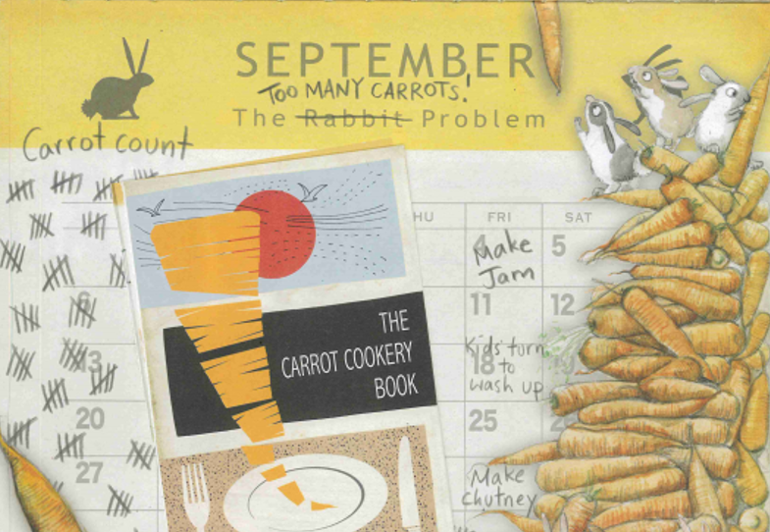
Discuss the answers to the following questions:
- What do you notice?
- What has happened to the rabbits?
- What might the problem be?
- Why do you think this?
- What might happen next?

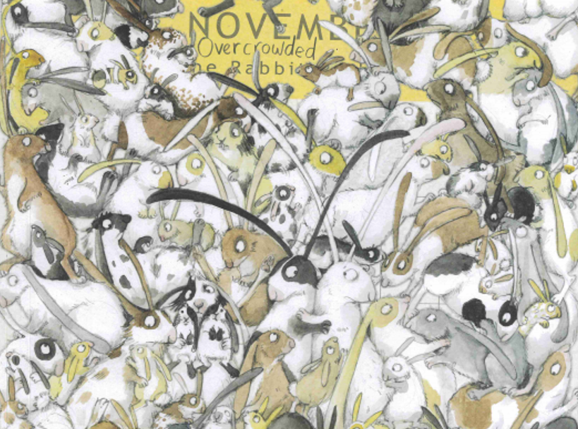
Activity 2
Have a look at the ‘Overcrowded Rabbit Problem’ page, it looks like this.

Discuss the answers to the following questions:
- What do you notice?
- What has happened to the rabbits?
- What might the problem be?
- Why do you think this?
- How do you think the rabbits are feeling? Why?

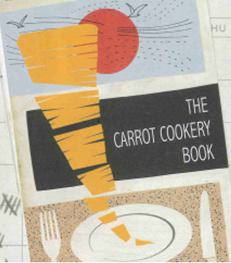
Activity 3

In September, the rabbits have too many carrots! We need your help to think of ways to use the carrots up!
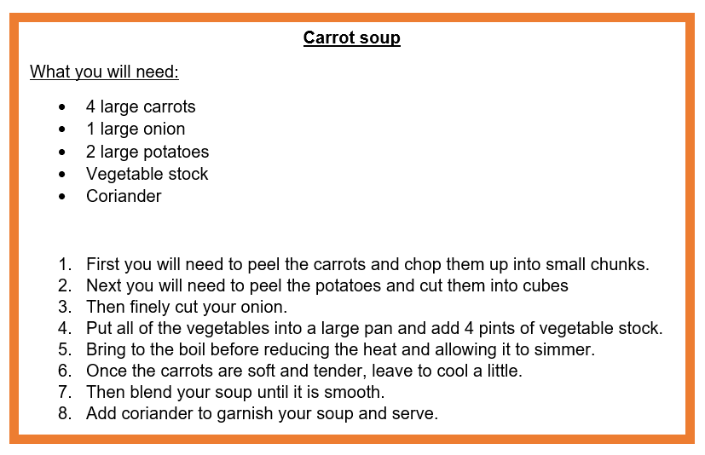
Can you write a recipe using carrots? Below are some ideas, but of course you may choose to use your own ideas!
- Carrot and potato soup.
- Carrot cake
- Beef stew with carrots.
- Carrot sticks
- Carrot patties
- Carrot chips
- Roasted carrots

Can you include some of the following features?
- Title
- You will need box
- Numbered steps
- Imperative verbs, also known as bossy verbs (eg get, put, cut)
- Pictures

Maths
This week, we would like you to tell and write the time for 5 minutes past the hour and 5 minutes to the hour.

You can use the clock you made last week to help you with your time learning.

Activity 1: Telling the time in 5 minutes intervals past the hour.

Watch the video using the link below about telling the time to 5 minutes past the hour.
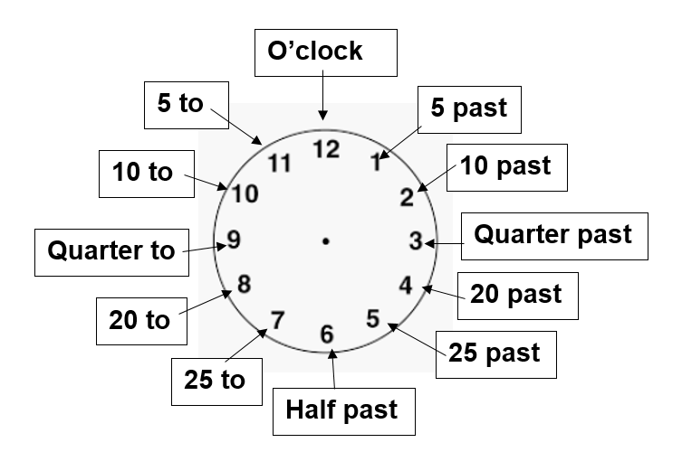
https://www.youtube.com/watch?v=hxlWDSKRAXc

Have a go at making these times on your analogue clock:

5 past 3 10 past 10
25 past 2 25 past 7
10 past 9 5 past 11
20 past 4 20 past 12
Now can you read and write the times that are shown on these clocks?

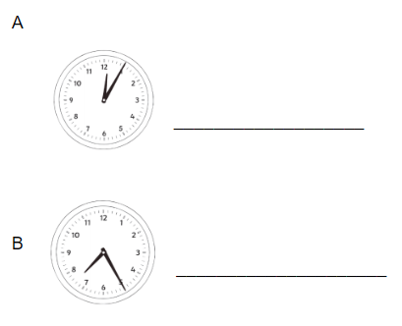
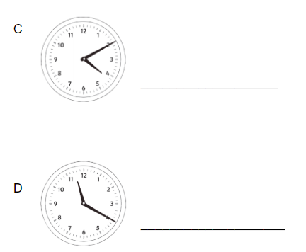

Activity 2: Telling the time in 5 minutes intervals to the hour.

Watch the video using the link below about telling the time to 5 minutes to the hour.
https://www.youtube.com/watch?v=tn32gups11k

Have a go at making these times on your analogue clock:

25 to 5 25 to 10
10 to 9 20 to 2
5 to 1 5 to 3
20 to 4 10 to 5

Now can you read and write the times that are shown on these clocks?
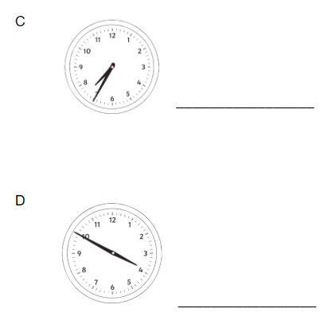
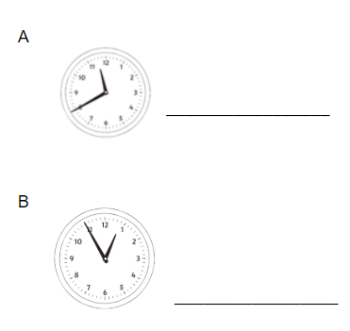

Activity 3: Match the clock to the correct time.
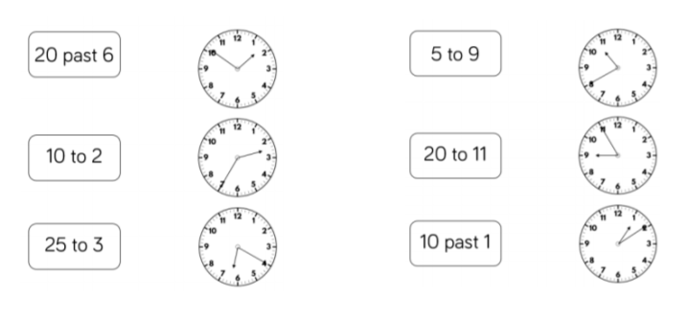

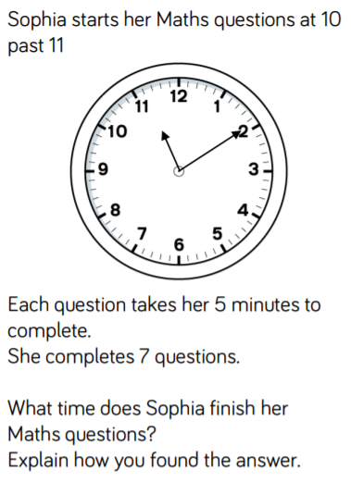
Challenge:
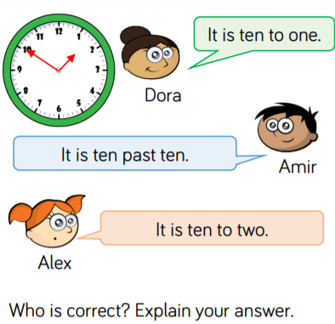

Want more maths? Try these extra activities!
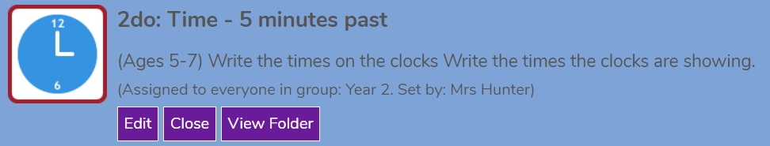
Play these games on Purple Mash.

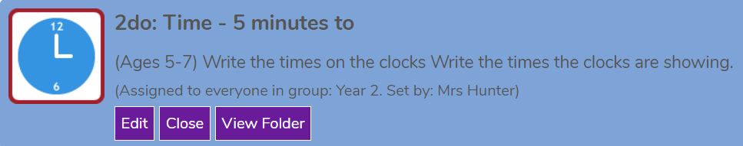

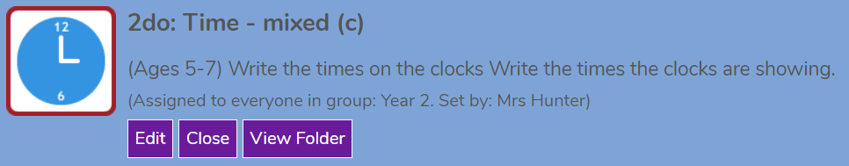

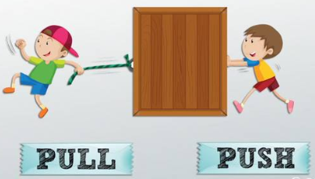
Science
This week you will be continuing your learning about forces.
The key ideas you will be focusing on are:
- Things can move in different ways
- Pushing and pulling can change the shape of things
- Pushing and pulling can make things move or stop

You can rewatch the following videos from last week to remind yourself about forces.
https://www.bbc.co.uk/bitesize/topics/zn77hyc/articles/zptckqt:

Activity 1 - How do things move?

We would like you to find items from around your house that can be pushed, pulled or twisted.
You could put your answers into a table like this, some items may fit into more than one category.

Push | Pull | Twist

Activity 2 - How does an item change shape?

Now we would like you to find items from around your house that can change shape when they are pushed, pulled or twisted. E.g an elastic band will get longer, if it is pulled.

You could put your answers into a table like this.

Push
Pull
Twist

Activity 3 - Designing your own toy
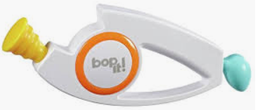
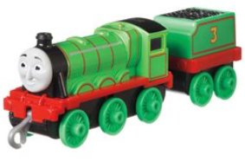
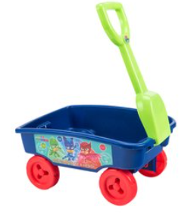
Can you design a toy that has a push, pull or twist mechanism? Below are some toys which include these mechanisms.

If you are finding it hard to design a new toy, you could draw a toy that you already have at home. Don’t forget, it needs to have a push, pull or twist mechanism.
Challenge
Can you write a sentence to describe which mechanism your toy uses (push, pull or twist)?

Project

This week we would like you to design or make a fruit salad that includes some exotic fruits, like those found in the Caribbean. You could even make a fruit kebab or a fruit smoothie!
Don’t worry if you do not have exotic fruits at home, you could simply use any fruits that you have. Alternatively you could design your fruit salad and draw it on a piece of paper. You could add labels to show which fruits you have included.

You will need to decide which fruits you will use. Below are some ideas:
- Pineapple
- Mango
- Passion fruit
- Strawberries
- Kiwi
- Orange
- Grapes
- Pear
Here are some questions to discuss whilst designing/making your fruit salad.
- Have you chosen a fruit you have never tasted before? Did you enjoy the taste?
- Where were the fruits grown? What conditions do the fruits need to grow?
- Which fruit was your most and least favourite fruit? Why?
Challenge
Choose 2 fruits that you used and write down which countries they came from?

Emailing Photos Using Purple Mash 2Email
You should now be able to upload photos onto purple mash by following the steps below:
- Open 2email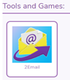 | - Compose new email
- Add teachers name to field and click on attach picture  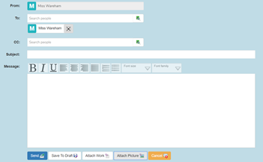 | - Click on 2nd icon - clipart  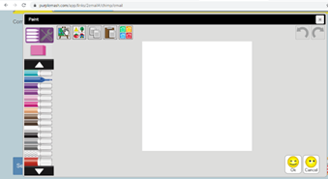
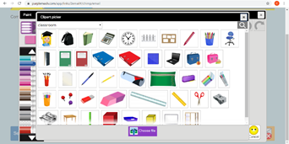  - Click on choose file | - You should then get the option to choose a file from your device, if you are using a tablet or phone it will give you the option ‘get photo’ and you can choose from your camera roll