Monday 15th November 2021

Dear Parents and Carers,

Thank you for your continued support in Year 1. As part of their project learning, the children are considering ‘Is Change Important?’ and are investigating the school grounds to find changes and things that have stayed the same.

Year 1 Number and Phonics support at home

Bug Club
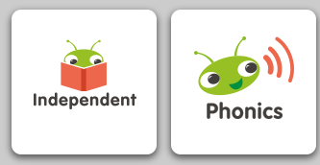
Each week, we will allow your child access to phonics games on the website Bug Club (https://www.activelearnprimary.co.uk/). Your child might have used this website in their Reception class so they may be familiar with it. We will select phonics games based on the sounds the children have been learning that week. We ask they complete at least one phonic game each week at home. We can also provide a paper phonics activity, if families are unable to access the resources online. Please let your child’s class teacher know if you would prefer this.
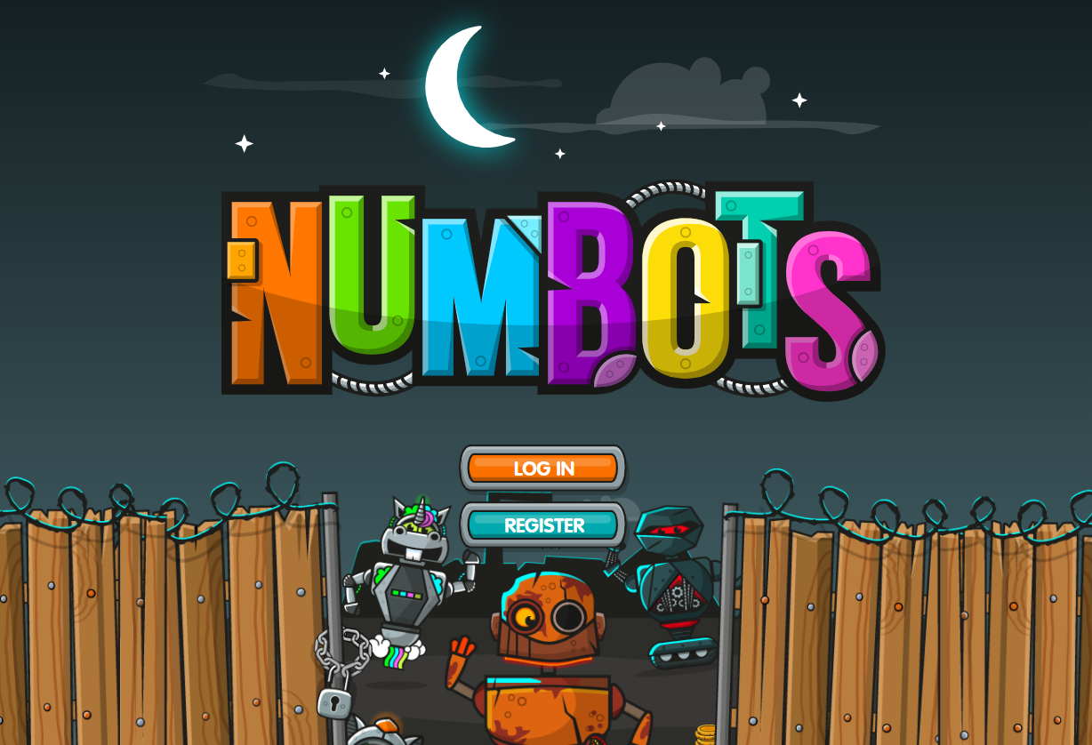
NumBots
NumBots is a mathematics programme that helps children develop their understanding, recall and fluency in mental addition and subtraction, so that they move from counting to calculating. The children can access this via the website https://numbots.com or by using the NumBots app. We would like the children to spend some time each week progressing through the NumBots stages.

Log in Details
We have stuck your child’s log in details for Bug Club (phonics and reading) and NumBots (number) on the last page of their Reading Log books.

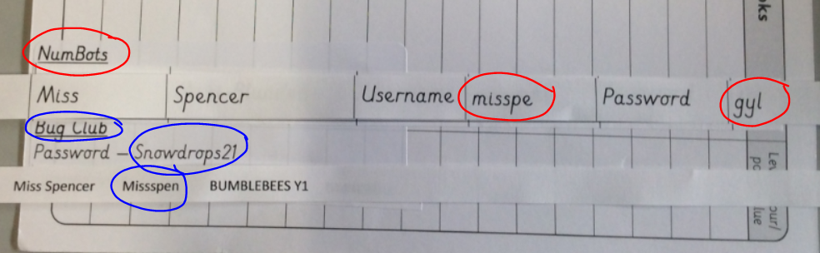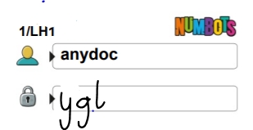

Year 1 Celebration Dates
We would like to invite the families so the children can share their learning with them. We will be going on a welly walk so please dress accordingly. We will be making clay pots, performing our fireworks dance and there will be an opportunity for you to look in your child’s books.

Wednesday 1st December 1.30pm – 3.00pm – AS1 Bumblebees
Thursday 2nd December 1.30pm – 3.00pm – CFLR1 Butterflies
Friday 3rd December 1.30pm – 3.00pm – LH1 Ladybirds.

Yours sincerely,

Miss Spencer/ Mrs Fryer/ Mrs Hunter/ Mrs Rodbourne,
Year 1 Team

